Building Product Information Sheet – Class 1

PRODUCT DETAILS:  OHOKA  Size: 230x76x70 (Nominal)  Units per m2: 48.5  Units per pallet: 624  Compression Strength Average: 37mpa  Dry Weight (per unit) Average: 1.60kg  Finished Wall Dry Weight Average: 115kg.  24H Cold-Water Absorption Average: 12.8%  L.R.V. (Light reflective Value): 50.08% | 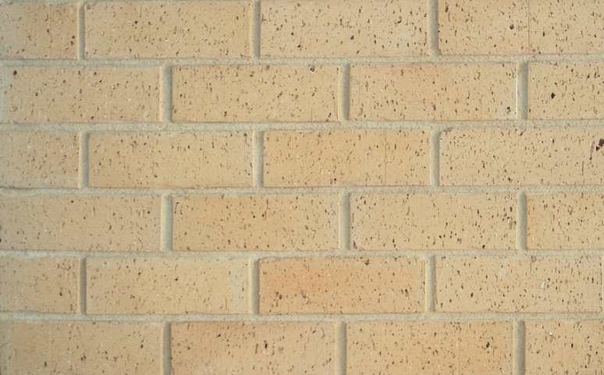

PRODUCT DESCRIPTION:
Canterbury Clay Bricks produce a range of kiln fired clay bricks. They are intended to be used in the construction of buildings and structures in conjunction with other materials not covered by this BPI sheet (Mortar and Brick ties).

PRODUCT IDENTIFIER:
Clay brick
COUNTRY OF MANUFACTURER:
New Zealand
LEGAL TRADING NAME OF MANUFACTURER: WD Boyes & Sons Ltd, T/A Canterbury Clay Bricks
ADDRESS FOR SERVICE: 1 Horndon Street, Darfield, Canterbury
Phone: 03 341 5036
Website: www.clay-bricks.co.nz
Email address: info@clay-bricks.co.nz
NZBN: 9429040360966

RELEVANT BUILDING CODE (NZBC) & HOW PRODUCT WILL COMPLY:
B1 Structure – B1.3.1, B1.3.2, B1.3.3 (F,h,m), B1.3.4.
Bricks are manufactured and tested in accordance with NZS4455 and NZS4456.
Bricks shall be laid and or overseen by a competent trade qualified brick layer. Refer SNZ 4236:2002 Best practice guide or Master Brick and blocking best practise guide.
B2 Durability – B2.3.1 (a), B2.3.2 (a,b).
Canterbury Clay Bricks guarantee bricks will be fit for purpose and will meet the 50-year durability requirement.
C3 Fire affecting areas beyond the fire source – C3.5, C3.6, C3.7.
Kiln fired clay bricks are non-combustible.
Used in a wall system see Branz fire rating on our website.
E2 External moisture – E2.3.2, E2.3.5, E2.3.7
Bricks should be laid in accordance with NZ3604.
F2 Hazardous building materials – F2.3.1
Kiln fired clay bricks are inert and do not omit any toxins. In their finished state clay bricks pose no threat to human health.
When bricks are cut procedures need to be followed to avoid breathing in dust. Refer Health and safety section in our technical manuals on website.

LIMITATIONS ON THE USE OF THE BUILDING PRODUCT:
This product is not designed to be in contact with the ground and/or used as a retaining structure to retain soil etc.
This product is not designed to be filled with concrete and used as a structural element (use timber or steel as the structure and clad in clay brick)

SELECTION OF PRODUCT:
Bricks will vary from batch to batch and will vary from any sample of photo you may have seen. It is important to view brick prior to laying and discuss with your bricklayer your desired finish.
Bricks are made from natural products and have minor imperfections like chips and cracks. See our Important notice in technical section of our website.

INSTALLATION REQUIREMENTS:
Bricks must be laid and/or overseen by a competent trade qualified tradesperson.
Refer to the Master Brick and Block Layer Association Best Practice Guide, clay-bricks.co.nz/technical- specification/ or SNZ HB 4236:2002 Best Practice Guide for Installation Requirements.

HEALTH AND SAFETY:
Correct PPE must be worn when handling bricks.
When cutting bricks always wear PPE and consider other working in the area.
See our health and safety notice on website under technical

MAINTENANCE REQUIREMENTS:
Canterbury Clay Bricks products shall be maintained by carrying out an annual inspection to ensure weepholes are clear and no loose or cracked bricks that may dislodge.
For cleaning and maintenance go to our website clay-bricks.co.nz/technical-specification
IS THE BUILDING PRODUCT/BUILDING PRODUCT LINE SUBJECT TO WARNING OR BAN UNDER SECTION 26:
No

